**Name:** Nada Abbas Mohamed

**Section:** 4

**ID:** 2015305

**Course:** Pattern Recognition and Image Processing

**Image Processing Basic Operations and Concepts**

1. ***Image Loading, Display, and Size Determination:***
2. Loading image:

Loading an image is simple only using cv2.imread() command in python and MATLAB imread() function. The loaded image could be read as a multichannel – BGR Image: cv2.imread(“img_name.img_type”,1), and could be read as a single channel - gray scale image: cv2.imread(“img_name.img_type”,0).

1. Display image:

Image display function in python is: cv2.imshow(“figure title”, img)

1. Size Determination:

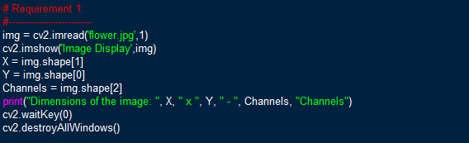Size of an image and the number of channels of the image could be determined using the function img.shape(). This function returns and array of data containing the 3 required characteristics.

1. ***Image Contrast Control:***

Contrast represents the degree of variance between a color and another – in other words the pixel and its neighbouring one. High contrast is the existence of 2 colors that could be distinguished exactly from each other, while for low contrast the color degrees are very near that they could not be easily distinguished.

Controlling the contrast in an image depends on the parameter alpha: 0:>1.

* if alpha is less than 1 then the image contrast is decreased – fig 2
* If alpha is larger than 1 then the contrast is increased – fig 3

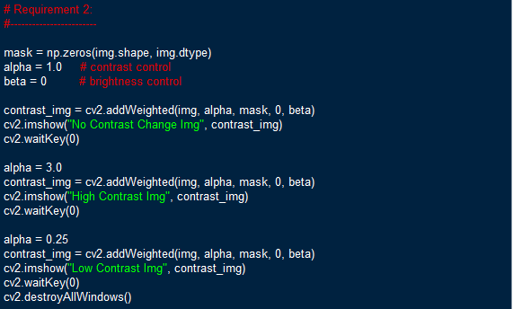

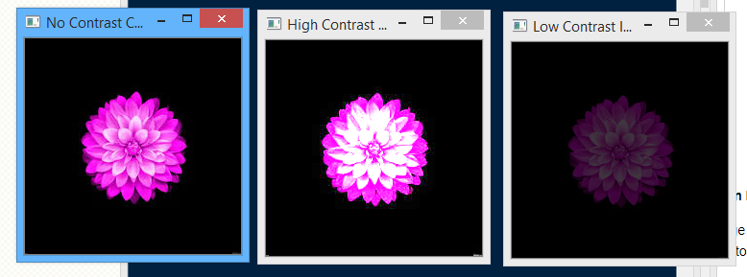

Fig 1: original fig 2: high contrast fig 3: low contrast

1. ***Image Zooming (Scaling):***

Image scaling is one of the most important techniques of image processing. Scaling of an image could be an up-scale or a down-scale. Zooming is different than scaling in the fact that scaling changes the size of the whole image, while zooming is enlarging a specific region in the image. Both zooming and scaling require interpolation enhancement.

Interpolation is an enhancement technique widely used for images. It is predicting intermediate values of pixels to overcome the fading of the image. Example: for up scaling an image the image pixels are remapped to fill the larger size of the window which cause image blurring and degradation, so interpolation adds additional pixels whose values are predicted according to the neighbouring pixels’ colors.

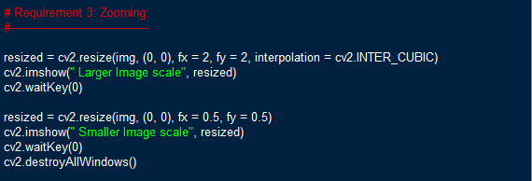

1. ***Image Rotation:***

The rotation operator performs a geometric transform which maps the position f(x1, y1) of a picture element in an input image onto a position(x2, y2) in an output image by rotating it through a user-specified angle theta about an origin. On rotating the image some parts are translated outside the boundary of the figure, in this case those parts are ignored.

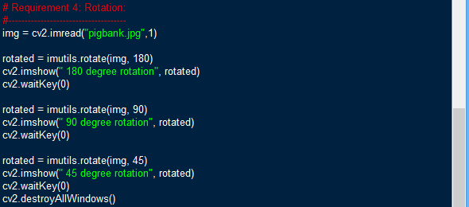

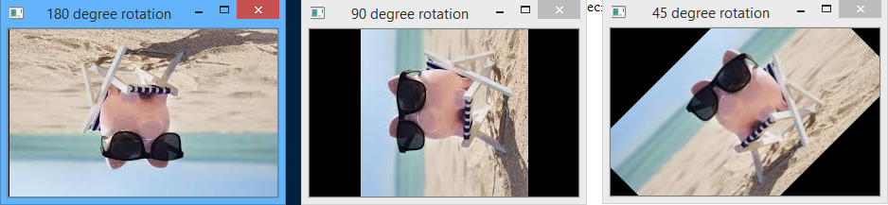

1. ***Image Histogram:***

Histogram is a statistical representation of the image intensity distribution. It graphically represent the usage of a specific color intensity all over the image. Histogram scale ranges form 0 to 2^n, where n is the bit depth – number of bits representing each pixel.

Histogram is very important it could be used for multiple purposes as detecting noise intensity in an image. Other than the statistical representation, histogram could be used for enhancement using either technique: histogram equalization, adaptive histogram equalization. Both of them redistributes the intensities on the image in an aim for visually enhancing the image, but histogram equalization redistributes the pixel intensity according to the whole image intensity probabilities, while the adaptive histogram equalization redistribute the pixel intensity based on the neighbouring pixels. In most cases AHE is better than common histogram equalization technique.

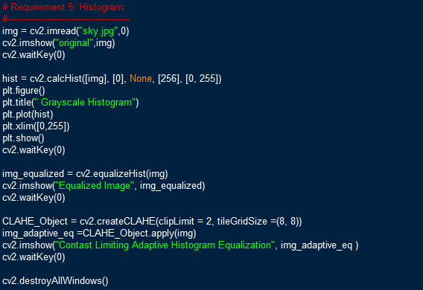

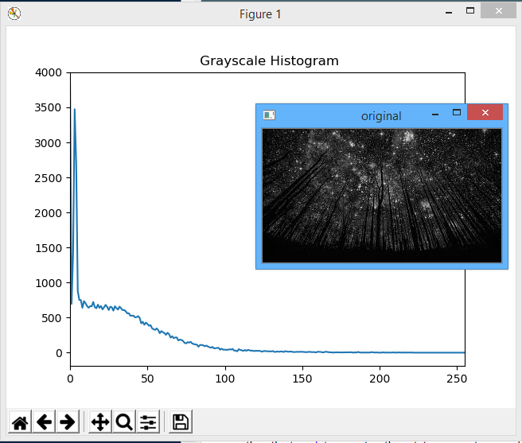As seen in the resulted graph, the image contains high intensities of black color.

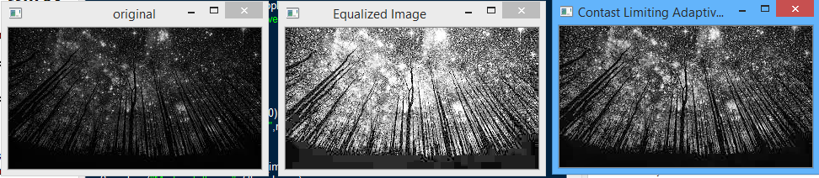

1. ***Image Filtering:***

Is a technique used for modifying or enhancing an image like highlighting, or removing certain features. It is used for multiple processes but the most know is noise filtering. Noise filtering is usually done in frequency domain through specifying the noise frequency then eliminating it. As an example for image filtering, I used a salt and pepper distorted image. Salt and pepper noise is a Gaussian noise which has a specific intensity either white or black. It appears as small dots distorting the image frame. I used 2 types of statistical filters both didn’t remove the noise permanently but also caused image blurring. Dealing with filters requires lots of try and error to specify the most appropriate filter for enhancing your image.

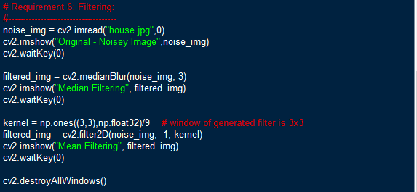

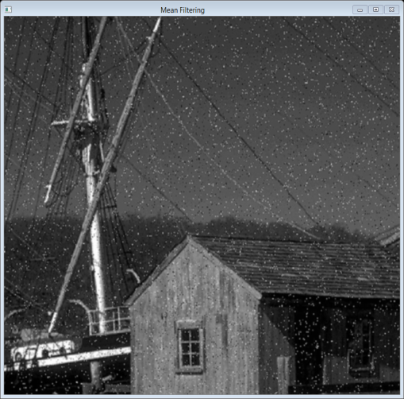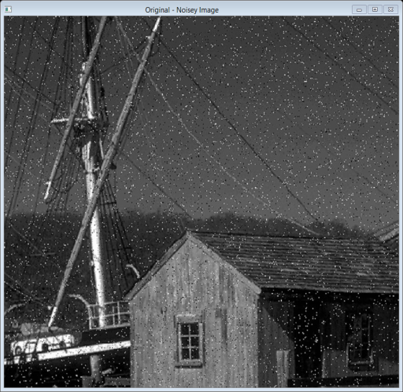 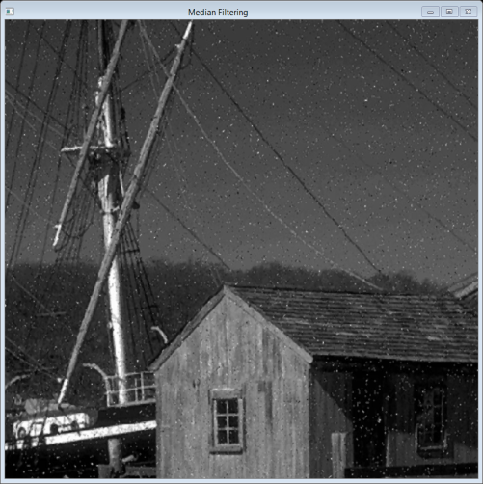

Median filter has decreased the noise but also caused blurring of the image, while the mean filter almost did not affect the noise.

1. ***Object Detection:***

Object detection is a computer technology related to computer vision and image processing that deals with detecting instances of semantic objects of a certain class (such as humans, buildings, or cars) in digital images and videos. Object detection is used in multiple applications.

Object detection depends on capturing the specific features of the object as every object have characterizing features that could be used to identify it. First we get the contours of the image from which we are able to detect the existence of the object.